**Conclusion**

**Given the provided data, what are three conclusions we can draw about Kickstarter campaigns?**

**1a.** Out of three states if we see the successful rate which is more than 50% for this Kickstarter project whereas canceled rate is very less approximate 9% as compared to the failure which is approximate 38%.

Below image see sheet ‘Conclusion 1a’ in StarterBook.xlsx

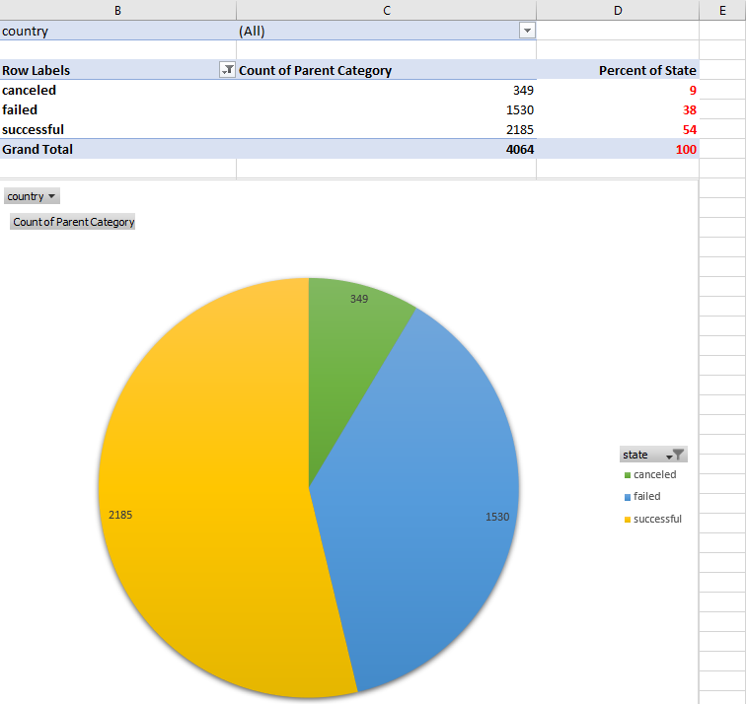

**1b.** Success rate for the two categories Music and Theatre is much more than other categories.

Below images see sheet ‘Conclusion 1b’ in StarterBook.xlsx

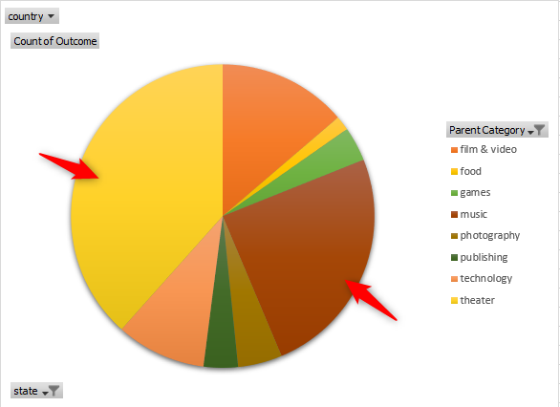

Whereas food is the category with highest failure rate.

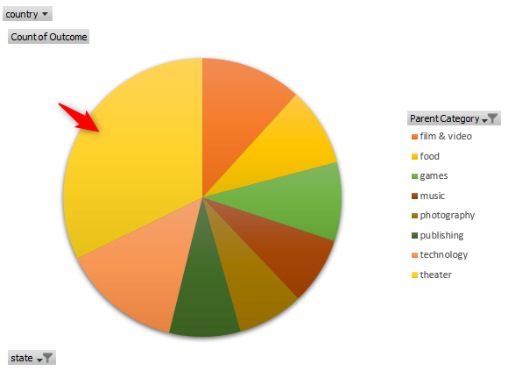

**2.** Out of all the subcategories ‘**Plays**’ is the only subcategory which very famous for the Kickstarter project.

Below images see sheet ‘Pivot & Chart - Sub Category’ in StarterBook.xlsx

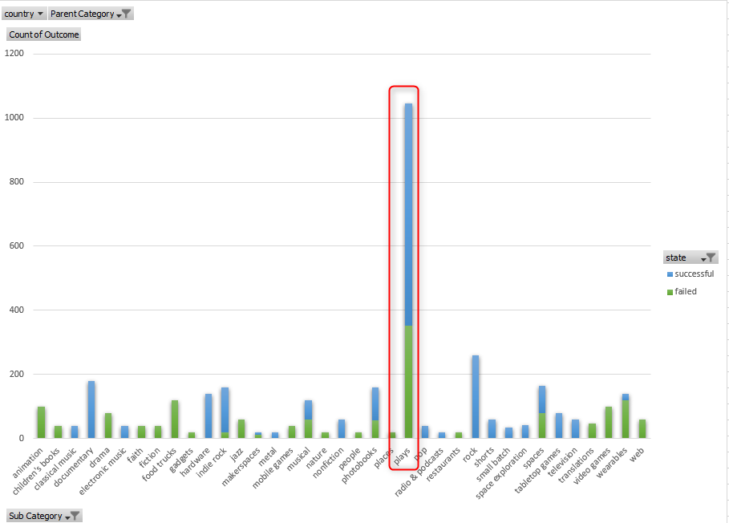

**3.** If we look at the below line chart, the data shows the increase in the failure rate from the month of April, while the success rate starts decreasing from the month of May. And by the year end around the Dec the failure rate crosses the success rate.

Below images see sheet ‘Pivot & Line Chart’ in StarterBook.xlsx

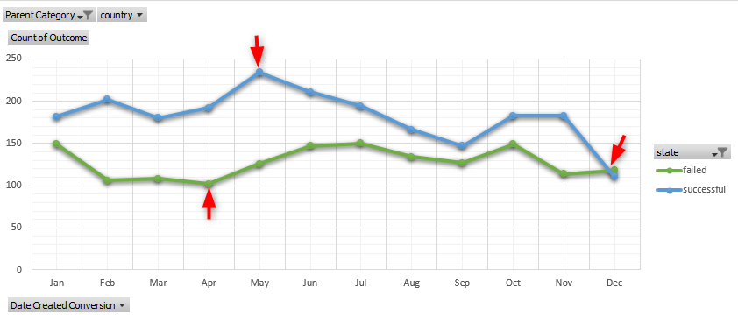

**What are some limitations of this dataset?**

The present data in the StarterBook dataset is small and not relevant enough to derive the results up to a satisfactory level.

**What are some other possible tables and/or graphs that we could create?**

Below are some graphs can be created same as I used above to find the rate of the State as used in my above conclusion: Refer images in sheet ‘Conclusion 1a & 1b’ in StarterBook.xlsx





